TRADE OF
Pipefitting

PHASE 2

Module 4

Pipe Installation

UNIT: 4

Bracket Fabrication

Produced by

In cooperation with subject matter expert:

Finbar Smith

© SOLAS 2014
Table of Contents
Unit Objective 1
Learning Outcome 2
1.0 Pipe Supports 3
1.1 Types of Pipe Supports 3
1.2 Primary Pipe Supports 4
1.3 Secondary Pipe Supports 5
1.4 Types & Use of Secondary Pipe Supports 6
2.0 Installing Pipe Supports 8
2.1 Installation of Pipe Supports 8
2.2 Spacing of Pipe Supports 9
2.3 Equipment Location and Supports 10
3.0 Thermal Expansion &Contraction in Piping Systems 11
3.1 Thermal Expansion and Contraction 11
3.2 Calculate the Thermal Expansion for Steam Pipe 13
4.0 Bracket Fabrication 14
4.1 Trapeze Bracket 15
4.2 Cantilever Bracket 16
4.3 Hanging Bracket 17
Exercises 18
Additional Resources 19

Unit Objective
There are six Units in Module 4. Unit 1 focuses on Introduction to Pipe Installation and Safety, Unit 2; Piping Services, Unit 3; Electricity on Site, Unit 4; Bracket Fabrication, Unit 5; Ancillary Piping Equipment and Unit 6; Piping system assembly.
In this unit you will be introduced to bracket fabrication, pipe installation and the effects of thermal expansion on pipe installations.
Module 4

Pipe Installation
Unit 1

Introduction to Pipe installation and Safety
Unit 2

Piping Services
Unit 3

Electricity on Site
Unit 4

Bracket Fabrication
Unit 5

Ancillary Piping Equipment
Unit 6

Piping System Assembly

Learning Outcome
By the end of this unit each apprentice will be able to:
- Identify and describe the different types of brackets used in the pipe fitting industry.
- List criteria for the selection of pipe brackets.
- List and describe various types of primary supports.
- List and describe various types of secondary supports.
- Describe the effects of thermal expansion on piping systems and why supporting brackets must be designed to facilitate movement.
- Calculate materials for the 3 brackets and fill out a BOM as per Exercise No.’s 2.4.4a, 2.4.4b and 2.4.4c
- Fabricate trapeze pipe bracket as per Exercise No. 2.4.4a
- Fabricate cantilevered pipe bracket as per Exercise No. 2.4.4b
- Fabricate hanging pipe bracket as per Exercise No. 2.4.4c
- Check the bracket mounting area for concealed cables and fasten the cantilever bracket to the wall.

1.0 Pipe Supports

Key Learning Points
- Identify the difference between primary and secondary pipe supports
- Identify the purpose of primary pipe supports
- Identify the purpose of secondary pipe supports
- Identify the purpose of different types of secondary supports

1.1 Types of Pipe Supports
The subject, "Pipe Supports" is a much more complex subject than the term suggests. There are so many situations that a pipe can find itself in and in every case it will need to be supported. Pipe supports are subdivided into two main categories:
- Primary supports
- Secondary supports
The primary pipe supports systems are those supports that are a part of the infrastructure and fall under the prime responsibility of the civil and structural department. The secondary pipe support systems are more a part of the piping systems and as such fall under the prime responsibility of the mechanical piping contractor. While the prime responsibilities are divided there must be a cross over of responsibility to ensure co-ordination between the civil and mechanical disciplines to ensure the overall system design works.
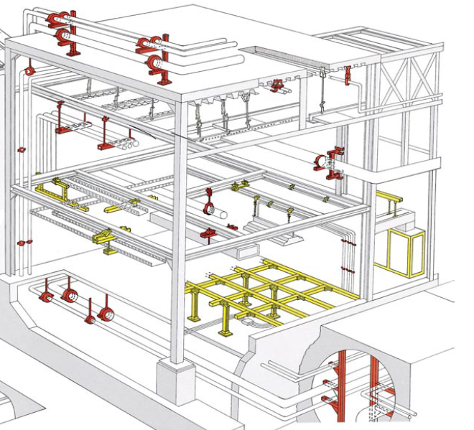
Figure 1 – Section through building showing primary and secondary supports

1.2 Primary Pipe Supports
Primary pipe supports systems are also be referred to as pipe racks, pipe ways, pipe alleys. These support systems may be major or minor and they may be overhead or sleeper pipe racks. It is important to understand that even though they are called pipe racks they support and carry more than just piping. These other items may include the cables for electrical and instrumentation services.
Overhead pipe racks (see figure 1 below) are elevated to the point where you can walk and/or drive under the supported piping. Sleepers or sleeper ways are low to the ground so there is no passage under the supported piping. Figure 3 below shows a pre-fabricated pipe rack being pre-loaded in a pipefitting workshop before installation to reduce time on site.
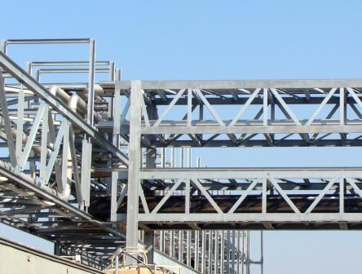
Figure 2 – Intersection of elevated pipe racks
When designing pipe racks many factors need to be considered such as:
- Overall layout and future development of the site. Racks should be sized to allow for future expansion of the facility
- Location of utilities equipment and services e.g boilers, chillers etc. and which buildings these services need to be distributed throughout the site.
- Configuration, will the support be a single column ("T") support or multi-column support? Poor planning of pipe rack intersections can cause major pipe installation issues later in the project.
- Height, will it be overhead or a sleeper design, how many levels are required for piping services and how many are required for electrical services.
- Width, a complete line list of all services to be piped plus a % for margin of error plus a % for client future expansion should be considered when setting the width. This may be rounded up to suit materials of construction / fabrication method.
- Spacing of pipes on the rack. Considerations such as pipe diameters, weight of pipes, weight of contents, insulated/non insulated, height of levels all need to considered when arranging pipes in the rack. Tie-ins, connections and branches also need to be considered as steam connections are made to the top of the pipe while condensate connections are made at the bottom of the pipe.
- Materials of construction/fabrication method- What materials are the pipe racks to be made of and what will be the fabrication method? Pipe racks can be bare steel, steel w/a concrete encasement (fireproofing), reinforced concrete or a combination.
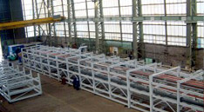
Figure 3 – Pre-fabricated and pre-loaded pipe racks prepared in a workshop

1.3 Secondary Pipe Supports
Secondary pipe supports cover a wide range of devices which can be sub divided into two categories:
- Engineered devices
- Miscellaneous pipe support devices.
Engineered pipe supports relates to devices that are non-static, one-of-a-kind, location and condition specific. They are identified at the time the need is recognized and then designed and engineered for that specific need. They can incorporate springs, and/or dampers to compensate for thermal expansion or contraction, or to provide vibration isolation, shock control, or vibration excitation of the pipe due to earthquake motion. These are designed and selected by the piping stress engineer and piping designer to ensure that the complete piping system functions correctly
Miscellaneous pipe support refers to a broad array of devices that includes items such as Anchors, Base Supports, Cradles, Dummy Support Legs, Guides, Hanger Rods, Pick-ups, Shoes, etc. Many different suppliers have different versions of these devices and client companies may opt to allow each pipe designer to select the most appropriate device or more commonly they will have a pre-engineered solution standardized to cover many similar type situations. Having pre-engineered solutions, saves money, reduces stock holding, provides consistency of design, results in a safer design and makes installation easier in the field as pipe fitters develop a consistent method of installation.

1.4 Types & Use of Secondary Pipe Supports
Table 1 below gives a list of names for typical secondary supports what they are used for and their frequency of use during normal operations. Table 2 gives images of secondary pipe supports and their common names.
Name | Purpose | Frequency
Anchors | Prevent the movement of the pipe line normally in a pipe rack | High
Base Anchors | Prevent any movement of a piping assembly normally at grade | Low
Base Guides | Allows only vertical movement (up or down) of piping assemblies at grade | Low
Base Supports | Provides support under piping assemblies normally at grade | High
Cradles | Provides protection for cold insulation when crossings a pipe support in pipe racks | High for cold service
Directional Anchor | Restricts the movement of a pipe line to a specific direction pipe racks | High
Dummy Support Legs | Provides added length to a pipeline for the purpose of support. Not restricted to only pipe rack usage | High
Field Supports | A catchall term sometimes used by a piping designer that includes any type of non-infrastructure support. These items are not location specific. | High
Guides | Provides restraint to keep a pipe line in place in horizontal pipe racks or vertical pipe racks in buildings or up tall equipment | High
Gussets | Provides added reinforcement for small (fragile) branch connections on a larger header or pipe | See note #1
Hanger Rods | A wide verity of top-down pipe supports situations, not location specific. | High
Hold Downs | Prevents or controls mechanical vibration in piping systems. | See note #2
Load Distribution Pads | Provides additional mass for thin wall pipe at a point of concentrated stress loading. This item is not location specific. | Low
Pick-ups | Provides support of pipes from other pipes or overhead beams and is not location specific. | Moderate
Shoes | Provides "mini-supports for lines with hot insulation normally only used only at pipe support points | High
Trunnions | Provides load-carrying points for vertical pipelines most often used to support pipes attached to tall vertical vessels or hung from tall structures. | Low
Table 1 – Secondary supports, purpose and frequency of use
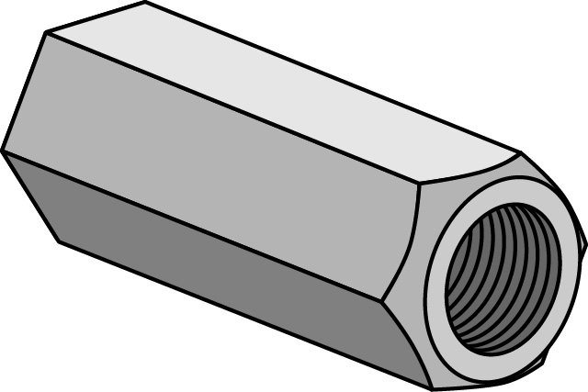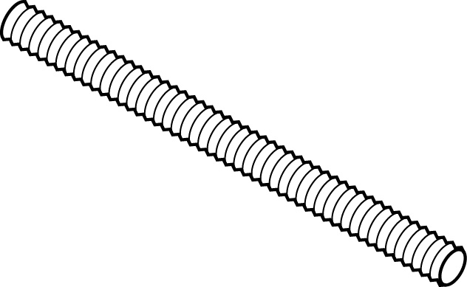 | 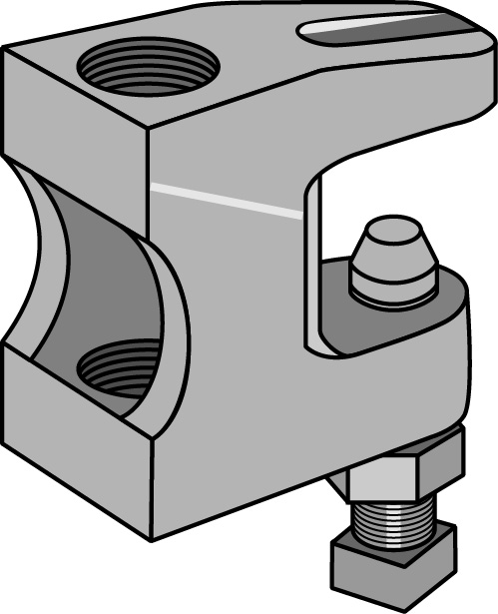 | 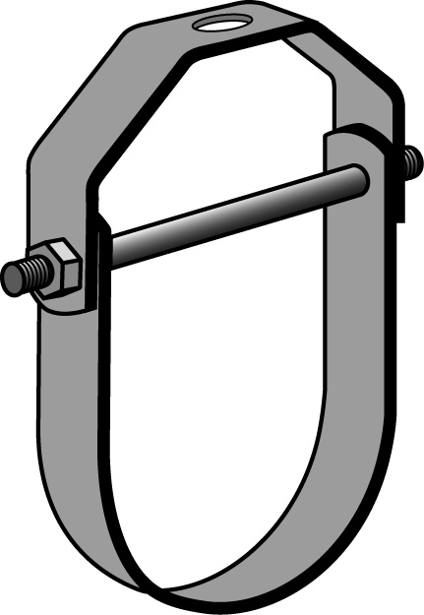
Threaded rod & coupling | Beam Clamp | Steel Pipe hanger
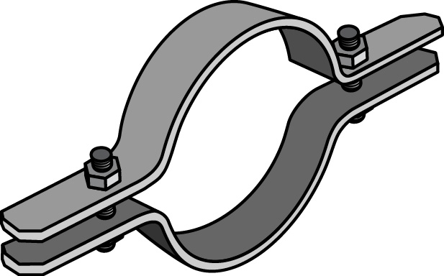 | 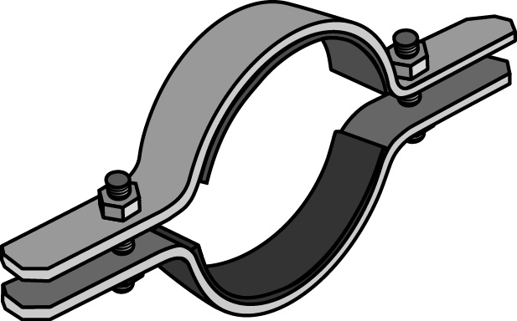 | 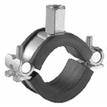
Standard pipe clamp | Rubber lined pipe clamp | Pipe clamp with threaded rod connector
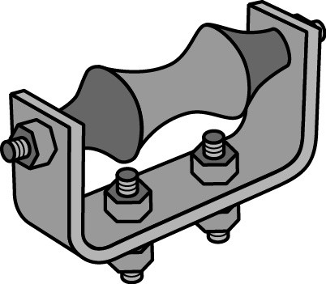 | 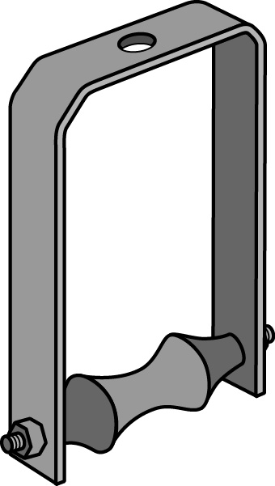 | 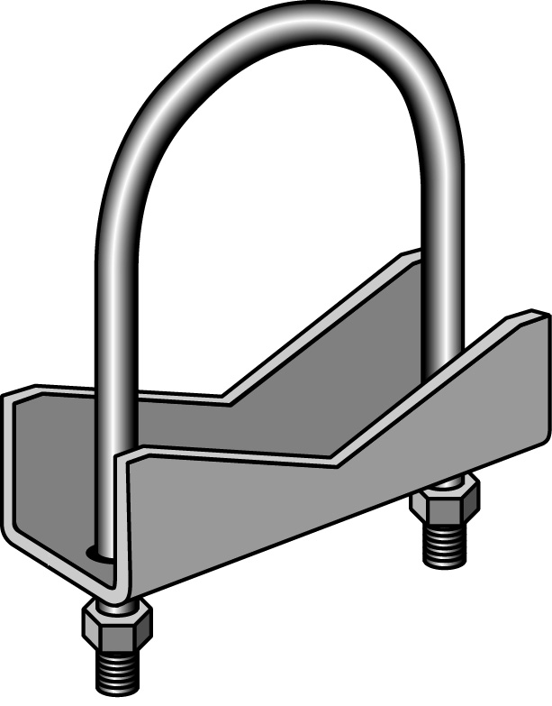
Pipe roller chair | Pipe roller hanger | Anchor chair with u-bolt
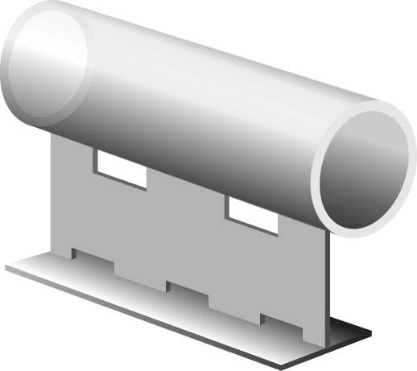 | 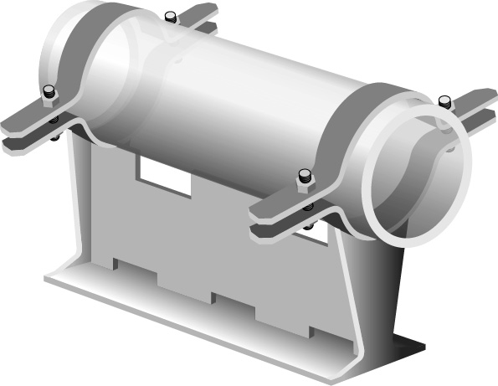 | 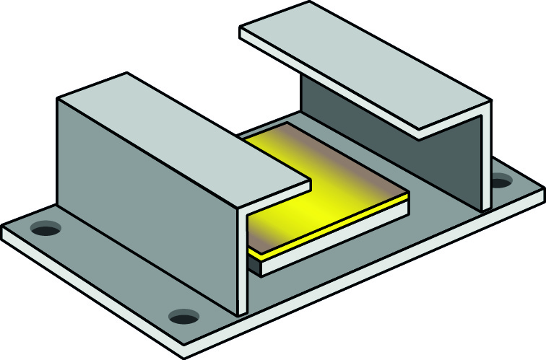
T pipe anchor | T pipe anchor with pipe clamps | PTFE hold down slide plate
Table 2 – Illustrations of common secondary supports and their names

2.0 Installing Pipe Supports

Key Learning Points
- Identify key guidelines for bracket installation
- Identify maximum spacing between pipe supports
- Identify requirements for equipment supports

2.1 Installation of Pipe Supports
As there are many different manufacturers and suppliers of secondary pipe supports it is not possible to provide specific installation instructions for secondary supports; however the following points should be observed for good piping installation practices.
It is important to verify that actual bracketing requirements are in accordance with client specifications, piping codes applicable to the project and are supervised and signed off by relevant personnel.
- Do not support piping from other piping.
- Support fire sprinkler piping independently of other piping.
- Arrange for grouping of parallel runs of horizontal piping to be supported together on trapeze type hangers where possible.
- Install additional attachments where support is required for additional concentrated loads, including manual and control valves, specialties, flanges, guides, strainers, expansion joints, and at changes in direction of piping.
- When using threaded drop rods for single hangers ensure all necessary inserts, bolts, rods, nuts, washers and other accessories are used.
- Install hangers and supports to allow controlled movement of piping systems and to permit freedom of movement between pipe anchors, and to facilitate action of expansion joints, expansion loops, expansion bends and similar units, if provided
- Load Distribution: Install hangers and supports so that piping live and dead loading and stresses from movement will not be transmitted to connected equipment, and so that maximum pipe deflections allowed by Pressure Piping Codes are not exceeded.
- Adjust the length of hangers so as to distribute loads equally on all supports.
- Do not use wire or perforated metal to support piping.
- For sanitary or hygienic pipelines that must be sloped to ensure that the system is free draining, install hangers and supports to provide pipe slopes indicated.
- Where piping of various sizes are to be supported together by trapeze hangers, space hangers for smallest pipe size or install intermediate supports for smaller diameter pipe. Conform to the table for maximum spacing of supports.
- Piping connected to equipment mounted on vibration control products; install isolation hangers for first three points of support for pipe sizes 4" and less, for first four points of support for pipe sizes 6" through 8", and for first 6 points of support for pipe sizes 10" and over. Locate isolation hangers as near overhead support structure as possible. Weld riser isolator units in place as required preventing displacement from loading and operations.
- Unless indicated otherwise or in clean spaces, for services operating at 65°C and above, use roller hangers and protective saddles. For services below this temperature, use clevis hangers and protection shields. All shields and saddles are to be a minimum of 30cm in length, sized per pipe size and insulation thickness and of a gauge thickness as indicated within the clients’ specification and the manufacturer's recommendation.

2.2 Spacing of Pipe Supports
In general, the table 3 shows the requirements for minimum rod sizes and maximum spacing, for different pipe sizes unless otherwise indicated on the piping drawings or client specific support requirements.
Nominal Pipe Size (") | Max Span (m) | Min Rod Size (mm)
<1 | 2 | 8
1 to 1 1/4 | 2 | 10
1 1/2 | 2.7 | 10
2 | 3 | 10
3 | 3.6 | 12
4 | 4.2 | 16
6 | 5.1 | 20
8 | 5.8 | 20
10 | 6.7 | 20
12 | 7 | 25
Table 3 – Maximum spacing and threaded rod size for different pipe sizes
In addition to the above requirements the following points are recommended:
- Provide a support not over 30cm from each change in direction pipe fitting joint and not over 1.5m from a valve.
- Support horizontal plastic piping runs, 1" and under in size, with a continuous "V" shaped metal runner between hangers, unless within clean areas.
- Support vertical runs at each floor.
- Clean area supports: Provide support in accordance with the client specification and as recommended by the manufacturer instructions for hygienic supports.
- Insulated Piping: Comply with the following installation requirements.
- Clamps: Attach clamps, including spacers (if any), to piping with clamps projecting through insulation,
- Shields: Where low-compressive-strength insulation is provided on cold systems, install protective shields. Provide high density insulation inserted between the pipe and shields to prevent crushing the insulation. Insert to have a compressive strength of 6.8 bar or better.
- Saddles: Hot piping systems, install insulation protection saddles welded to the pipe Space between saddles and pipe is to be insulated with same insulation as remainder of system.

2.3 Equipment Location and Supports
When installing and supporting equipment it is best refer to specific manufactures instructions for positioning and securing equipment. The following points should be observed.
- Ensure equipment is correctly positioned in relation to building gridlines and column centerlines.
- Locate anchor bolts using equipment manufacturer's templates.
- Use the correct size and of anchor bolts as recommended by the equipment manufacturer. (i.e. mechanical anchor bolts or chemical anchor bolts).
- Level equipment and grout under supports so as ensure equipment remain at the proper levels and elevations.

3.0 Thermal Expansion &Contraction in Piping Systems

Key Learning Points
- Identify the effects of thermal expansion and contraction in piping
- Identify solutions which address thermal expansion of pipes
- Calculate the thermal expansion of steam pipe

3.1 Thermal Expansion and Contraction
As piping is installed at ambient temperature, any piping carrying hot or cold fluids will expand or contract when it reaches its operating temperature. The expansion especially in length can create stresses at welded joints or upon certain areas of the piping distribution system. Piping systems designers must assess piping runs and identify where the natural flexibility of the pipe and fittings can absorb the stresses of thermal expansion and where design intervention is required. The following are some possible solutions for Cold draw: The pipe is pre-stressed (as in figure 4) in the opposite direction at ambient temperature (i.e. by tightening at a flange joint) so that when the system is heated the pipe expands and the stress is removed.
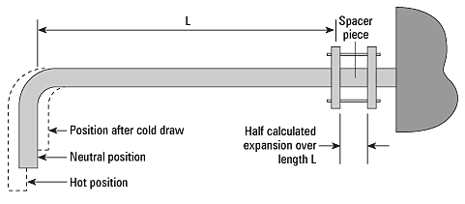
Figure 4 – Cold draw where pipe is pre-stressed at ambient installation
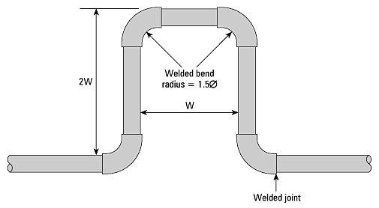
Expansion loops as seen in figure 5 below can be used on horizontal long runs of pipework and can be fabricated elbows and straight lengths of pipe. The expansion that these types of loops can allow for can be read from the table in figure 6.
Figure 5 – Expansion Loop for long straight runs of pipework
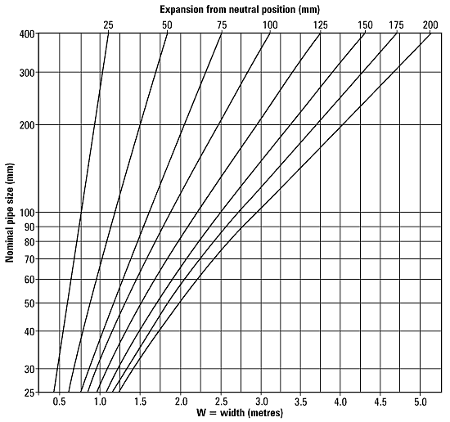
Figure 6 – Expansion from neutral position for carbon steel pipe
Sliding joints as seen in figure 7 are used because they take up little room but it is essential that the pipeline is rigidly anchored and guided in strict accordance with the manufacturers' instructions; otherwise steam pressure acting on the cross sectional area of the sleeve part of the joint tends to blow the joint apart in opposition to the forces produced by the expanding pipework. Misalignment will cause the sliding sleeve to bend, while regular maintenance of the gland packing may also be needed.
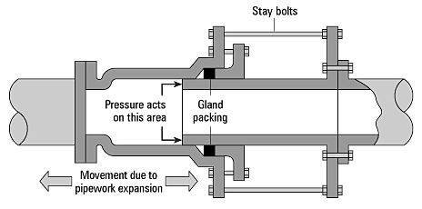
Figure 7 – Sliding joint
Bellows as seen in figure 8 has the advantage that it requires no packing but it does have the same disadvantages as the sliding joint in that pressure inside tends to extend the fitting, consequently, anchors and guides must be able to withstand this force. There is more than one way to accommodate the relative movement between two laterally displaced pipes depending upon the relative positions of bellows anchors and guides. In terms of preference, axial displacement is better than angular, which in turn, is better than lateral. Angular and lateral movement should be avoided wherever possible. but, under all circumstances, it is highly recommended that expert advice is sought from the bellows' manufacturer regarding any installation of expansion bellows.
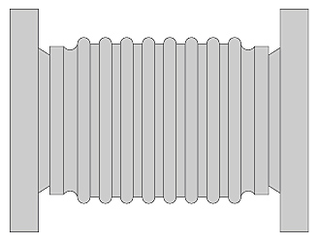
Figure 8 – Expansion bellows
If expansion solutions are employed it is essential that the pipe line is properly anchored at the correct positions and that guides are used to ensure that any movement does not interfere with other piping systems or equipment in the vicinity. It is good practice for pipework to be supported on rollers to facilitate the expanding pipe and keep it in alignment while expansion and contraction occurs.

3.2 Calculate the Thermal Expansion for Steam Pipe
The amount of expansion in a pipeline can be calculated using the following formula:
Expansion = L x ∆_{t} x α (mm)
Where L = Length of pipe between anchors (m)
∆_{t} = Temperature difference ºC
α = Expansion coefficient (mm/mºC) x 10⁻³
 | Temperature Range ºC
Material | <0 | 0-100 | 0-200 | 0-315 | 0-400
Mild Steel | 12.8 | 14.0 | 15.0 | 15.6 | 16.2
Stainless steel | 9.4 | 20.0 | 20.9 | 21.2 | 21.8
Table 4 – Expansion coefficients (α) for mild and stainless steel
Calculate the amount of expansion in 30m of steam pipe which was installed at an ambient temperature of 10ºC and an operating pressure of 4 Barg (152 ºC)
Expansion = L x ∆_{t} x α (mm)
Where L = 30m
∆_{t} = 152ºC - 10ºC = 142ºC
α = 15.0 x 10⁻³ mm/mºC
Expansion = 30 x 142 x 15.0 x 10⁻³
Expansion = 64mm

4.0 Bracket Fabrication

Key Learning Points
- Calculate materials for the 3 brackets and fill out a BOM as per Exercise No.’s 2.4.4a, 2.4.4b and 2.4.4c
- Fabricate trapeze pipe bracket as per Exercise No. 2.4.4a
- Fabricate cantilevered pipe bracket as per Exercise No. 2.4.4b
- Fabricate hanging pipe bracket as per Exercise No. 2.4.4c
- Final measurements of components within tolerances prescribed on the exercise sheets
- Check the bracket mounting area for concealed cables and fasten the cantilever bracket to the wall.
Practical Task
This is a practical task. Please refer to your instructor for additional information and instruction.

4.1 Trapeze Bracket
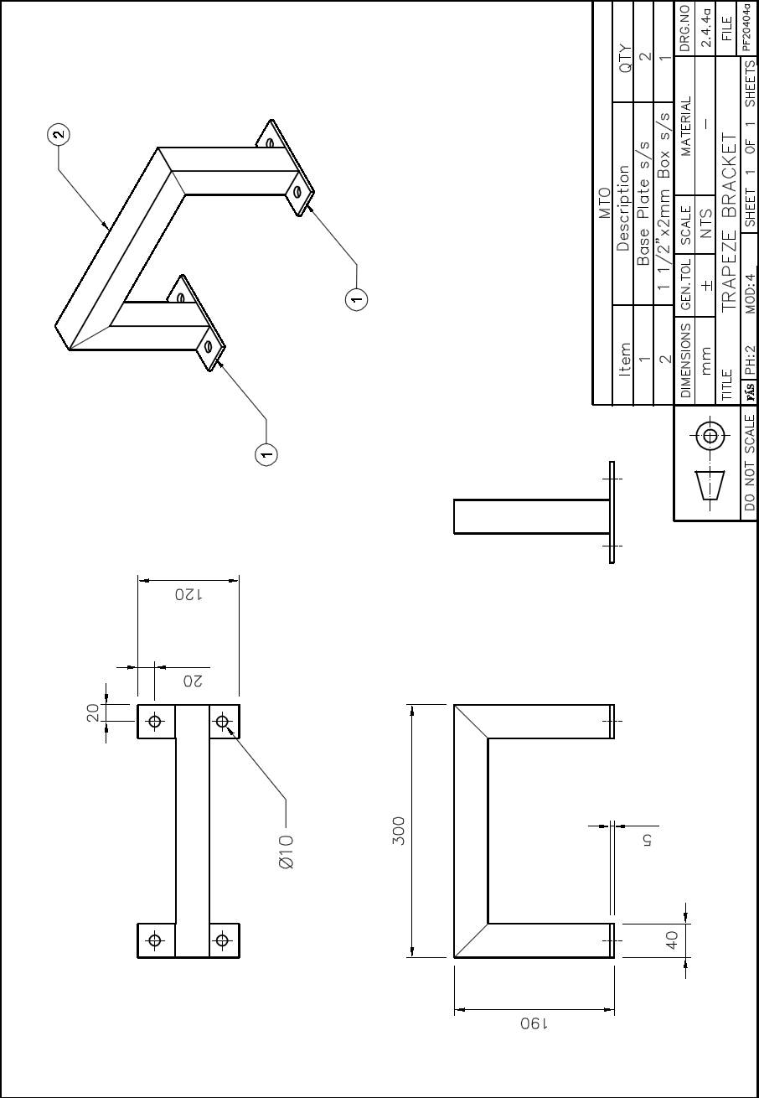

4.2 Cantilever Bracket
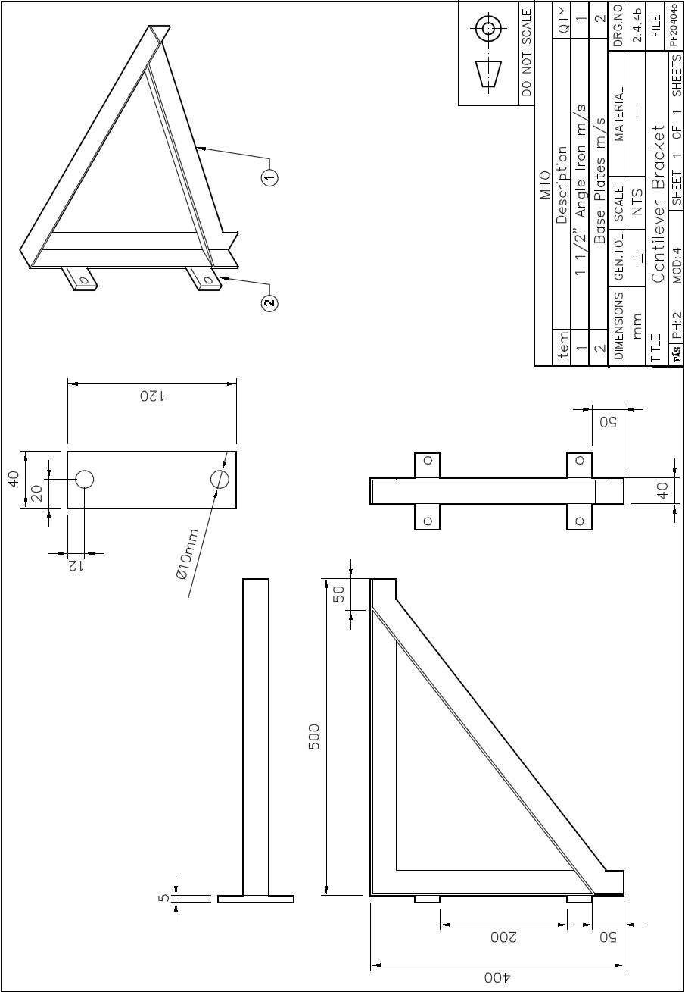

4.3 Hanging Bracket
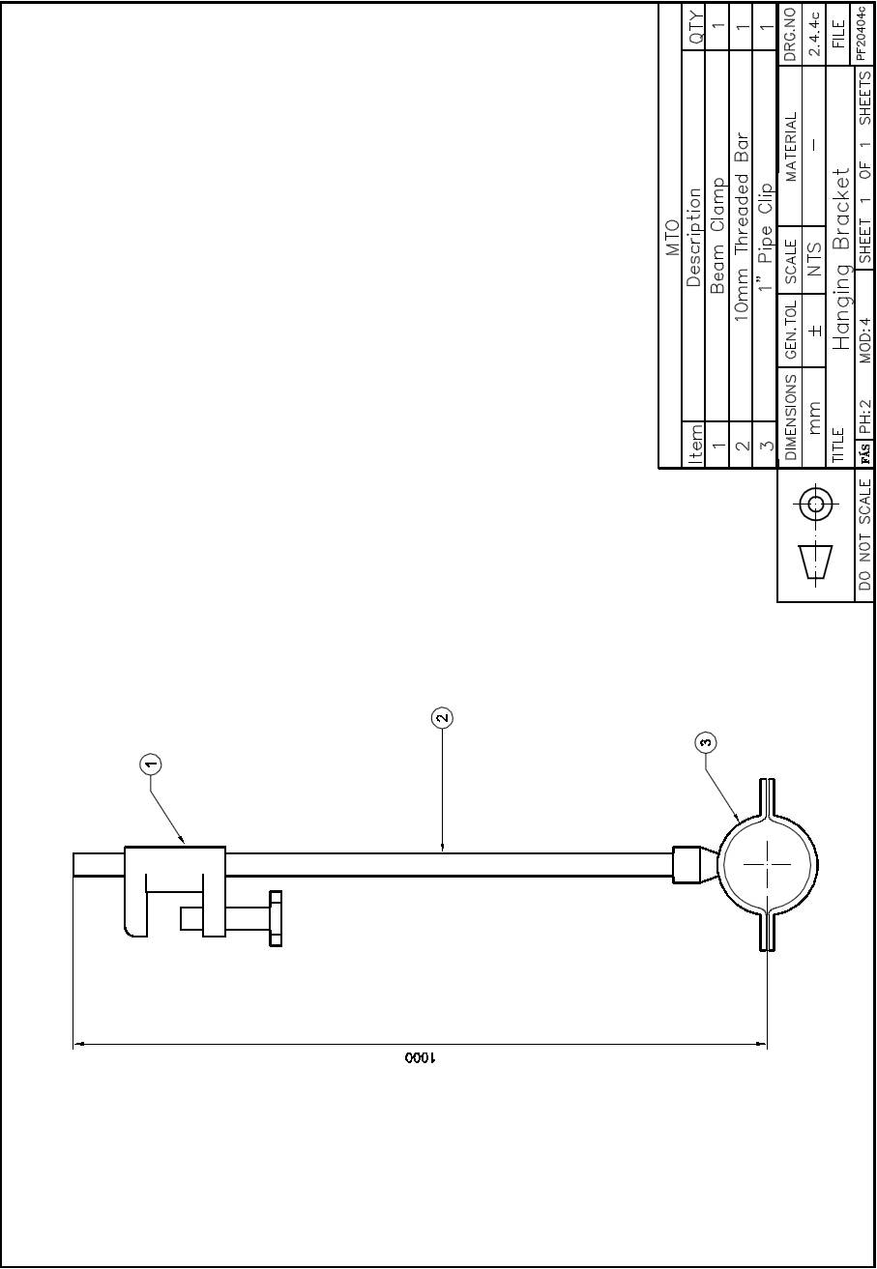

Exercises
- Calculate materials for the 3 brackets and fill out a BOM as per Exercise No.’s 2.4.4a, 2.4.4b and 2.4.4c
- Fabricate trapeze pipe bracket as per Exercise No. 2.4.4a
- Fabricate cantilevered pipe bracket as per Exercise No. 2.4.4b
- Fabricate hanging pipe bracket as per Exercise No. 2.4.4c
- Identify 2 solutions which are used to compensate for the thermal expansion of pipework

Additional Resources
Title | Author | Ref. Code
The Induction Book, “Code of Behaviour & Health & Safety Guidelines” | SOLAS
Pipe Supports, Part – 1 | James O. Pennock
Basic Welding and Fabrication | W Kenyon | ISBN 0-582-00536-L
Fundamentals of Fabrication and Welding Engineering | FJM Smith | ISBN 0-582-09799-1
Workshop processes, practices and materials, 3rd edition, Elsevier Science & Technology | Black, Bruce J 2004 | ISBN-13: 9780750660730
New Engineering Technology | Lawrence Smyth & Liam Hennessy | ISBN 086 1674480

Videos:
- Understanding welding fumes
- Welder on Site…Be Aware (Vocam)
- Powered hand tool safety (Vocam)
- Industrial Ergonomics (Vocam)
Available from:
Vocam Ireland
Circle Organisation Ltd
Friar Street, Thurles, Co Tipperary, Ireland
Tel: +353 504 24666

Castleforbes House
Castleforbes Road
Dublin 1

